Click on the “Run Program” folder to open

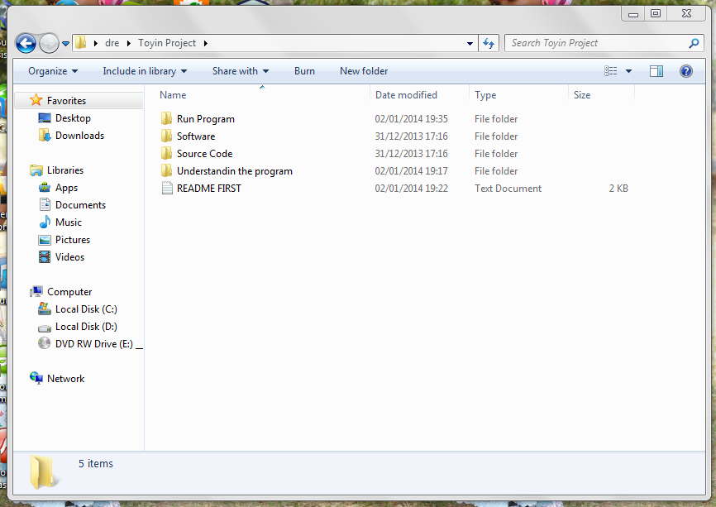

Double Click on “Package” to open. The next screenshot then opens 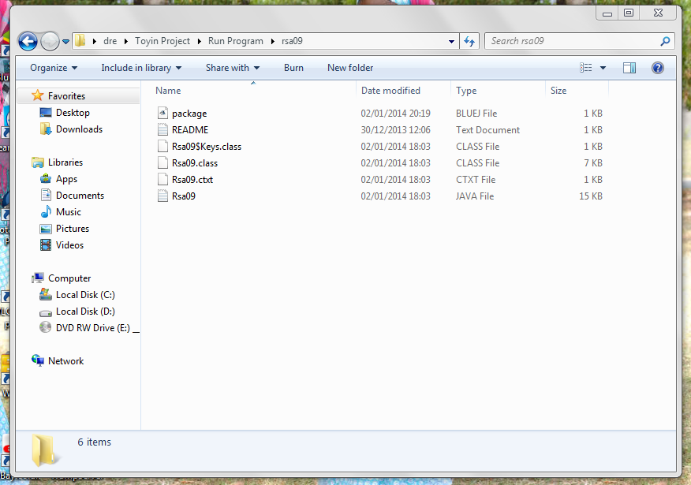

Double Click on “Rsa09” and the next screen shot opens, which is the source code window

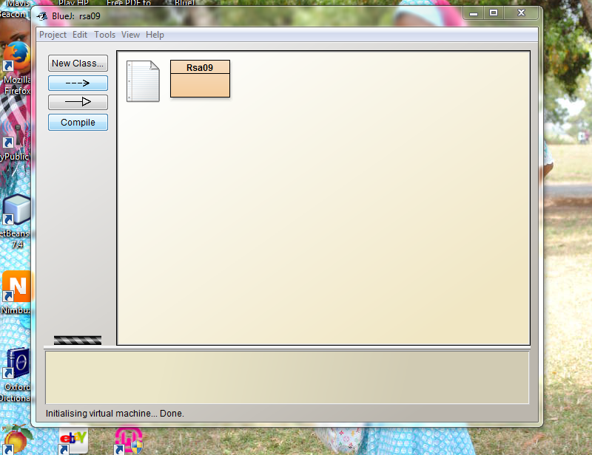

Here is the source code screen shot that appears

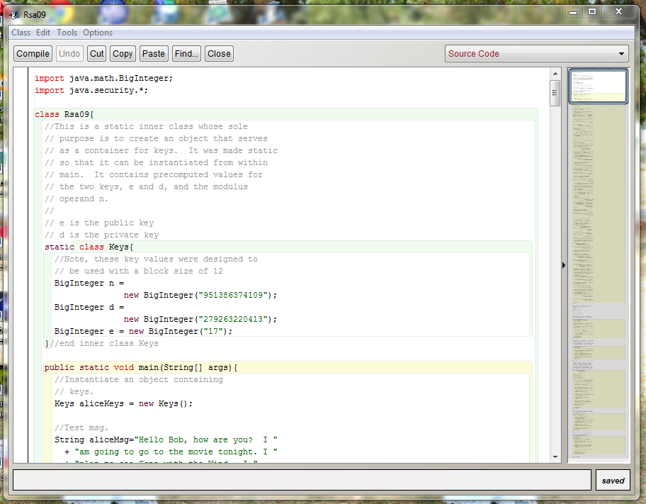

Now, go back to the bluej home page

Now Right Click Rsa09 to bring options then Select “void main (string args)” and the next screen shot appears. Click O.K then the output for the program appears just like the next screen shot, which tells us the signature is valid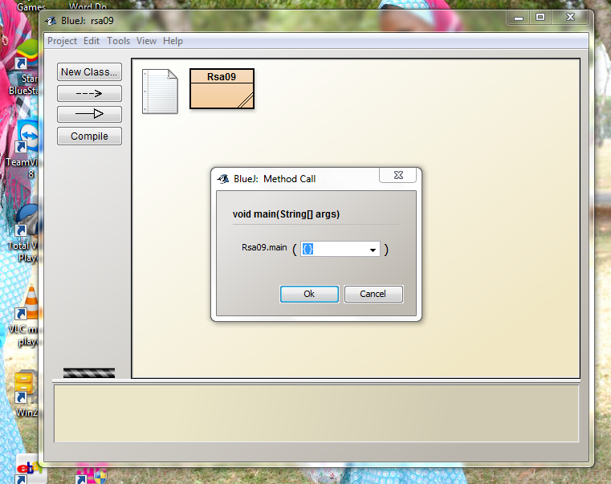

The below screen shot is the output program that confirms the signature to b valid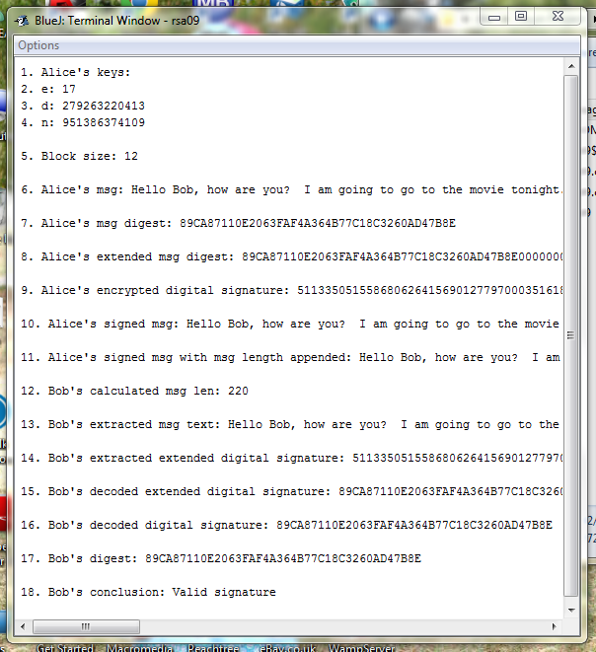

Now what we want to do next is to change something in the program so that we can have an output that will display invalid signature. Now go back to the source code window. In the line where we have big integer d= new big integer (“279263220413”), you can now try to change any of the number in quote and click compile. Then go to the home page and run it the way we did in the previous 1 to produce the output then you should have an output that says invalid signature.



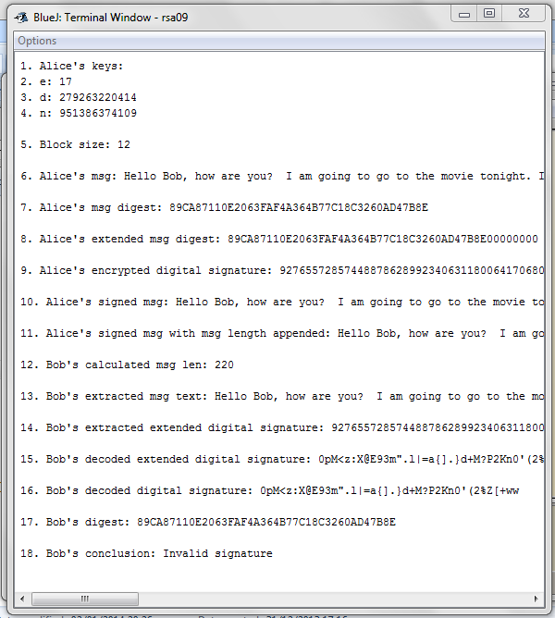

Now do the same thing for RSA10 too, it’s the same procedure

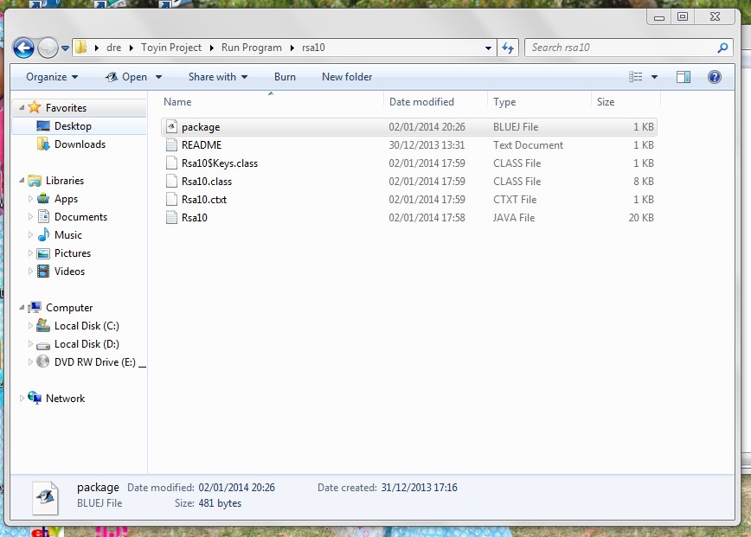

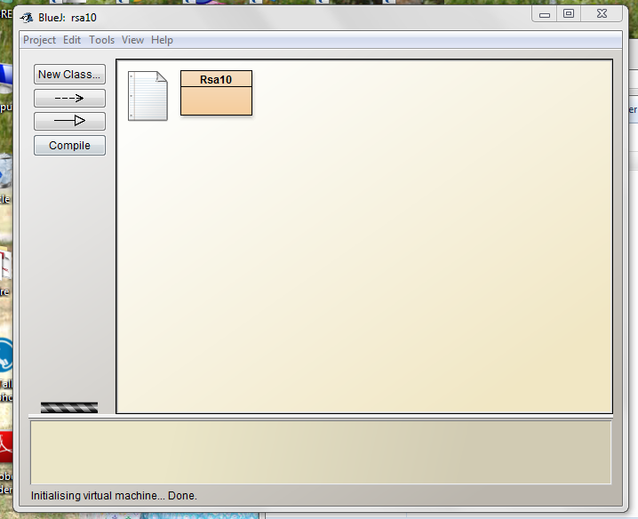

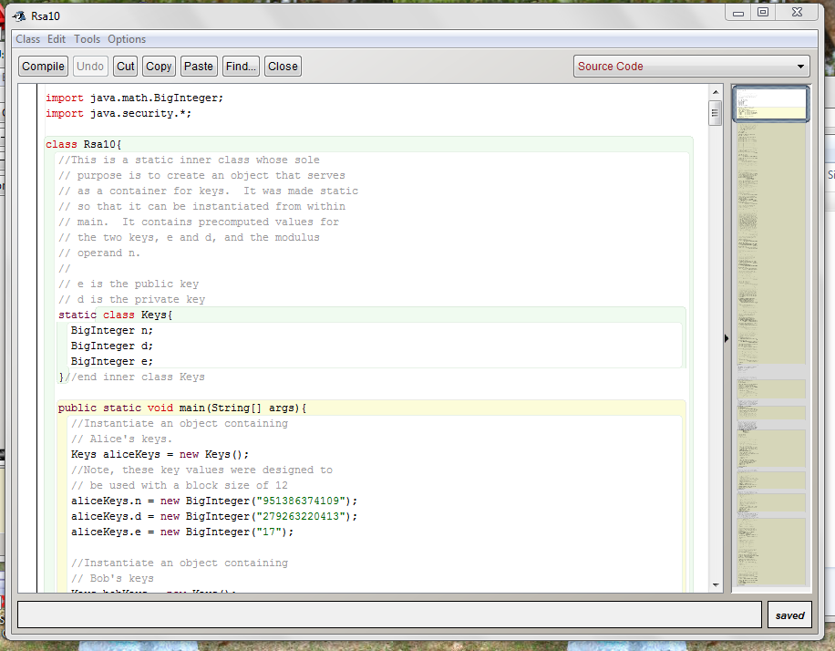

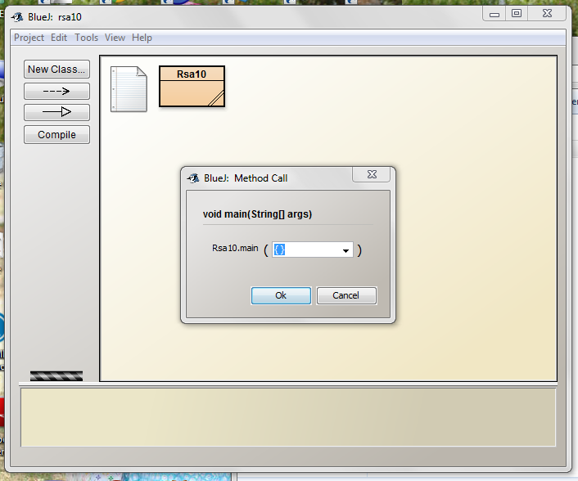

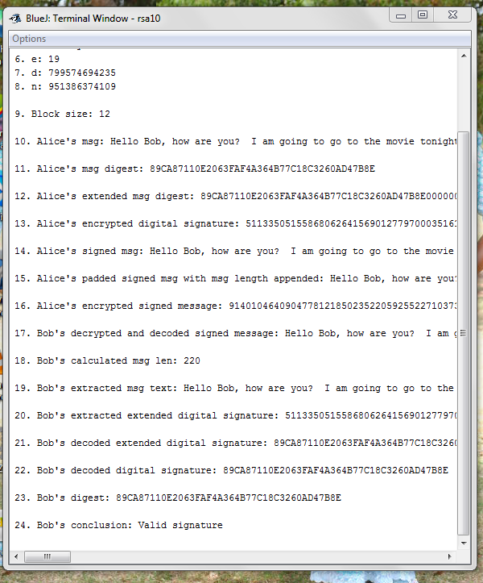

Here what you are going to change to produce an invalid signature output is the line where we have

Alice key.d=new biginteger (“279263220413”), change any of the number in quote then click on compile and run out the output. Then it should produce an invalid signature just like the screen shot below



